**Air University Multan Campus**

**Department of Computer Science and Engineering**

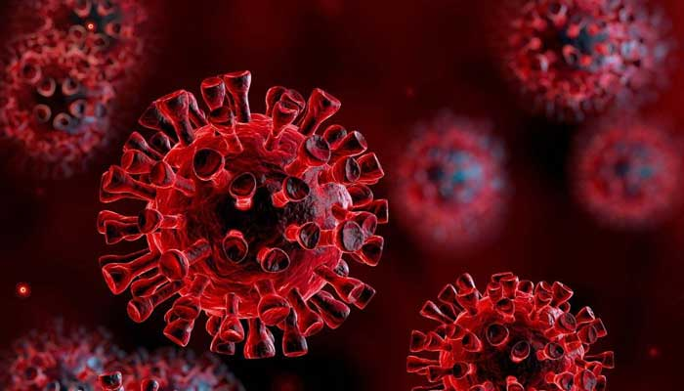

**<Covid-19 Updates>**

**Project Proposal**

Prepared by

|  |  |
| --- | --- |
| Group#: | Grade: |
| Group Email: [183158@students.au.edu.pk](mailto:183158@students.au.edu.pk), [183209@students.au.edu.pk](mailto:183209@students.au.edu.pk), [183220@students.au.edu.pk](mailto:183220@students.au.edu.pk) | |
| Group members: 3 | |
| *<Student1, ID ,Role>* | 183158 |
| *<Student2, ID, Role>* | 183209 |
| *<Student3, ID, Role>* | 183220 |

**Supervised by**

Mam Atka Ali

<6th> Semester <1442>

<Summer> <2021>

**Revision Table**

|  |  |  |  |
| --- | --- | --- | --- |
| **Page#** | **Section#** | **Reviewer** | **Corrected by (Reviewer, Author)** |
|  |  |  |  |
|  |  |  |  |
|  |  |  |  |
|  |  |  |  |
|  |  |  |  |
|  |  |  |  |
|  |  |  |  |
|  |  |  |  |

**Contents**

1. Introduction 4

2. Project Goals and Objectives 4

3. System Architecture 5

4. WIREFRAMES 5

5. OUTPUTS 8

# **Introduction**

Coronavirus disease (COVID-19) is an infectious disease caused by a newly discovered coronavirus.

On 31st December 2019, in the city of Wuhan (CHINA), a cluster of cases of pneumonia of unknown cause was reported to World Health organization. In January 2020, a previously unknown new virus was identified, subsequently named 2019 novel corona virus. WHO has declared the COVID-19 as a pandemic. A pandemic is defined as disease spread over a wide range of geographical area and that has affected high proportion of the population.

As the time passes, number of coronavirus cases are increasing day by day due to the negligence of people. COVID-19 is mainly transmitted through droplets generated when an infected person coughs, sneezes, or exhales. These droplets are too heavy to stay in the air, and quickly fall on floors or surfaces. People can be infected by breathing in the virus if they are within close proximity of someone who has COVID-19, or by touching a contaminated surface and then your eyes, nose or mouth.

# **2. Project Goals and Objectives**

This project have the following goals and objectives:

* **Origin of coronavirus**: From where it has started.
* **Effect of corona virus**: How corona virus will affect our lives and routines.
* **Symptoms of coronavirus**: How people will come to know whether they have corona or not by sharing their symptoms.
* **Advantages and disadvantages of lockdown**: How lockdown has affected people’s life. How lockdown has saved people from being affected by corona virus.
* **Unemployment rate in Covid**-19: How lockdown and Covid has affected businesses of people.
* **Seasonal effects of Covid 19**: How season is affecting corona virus cases
* **Precautions and SOPS**: What will be the effect of SOPS if followed in offices and educational institutes?
* **Vaccine:** Speeding up the development of safe and effective vaccines against Covid-19. Vaccine registration form.
* **Confirmed cases:** How the number of confirmed cases increasing day by day, month wise and per year.
* **Recovered cases:** How the number of recovered cases increasing day by day, month wise and per year.
* **Death Cases**: How the number of death cases increasing day by day, month wise and per year
* **Active cases**: How many number of cases are currently active?
* **Complaint form**: User can enter complaint against positive corona patients.

# **3. System Architecture**

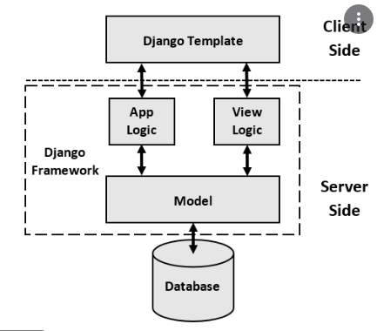

# **4. WIREFRAMES**

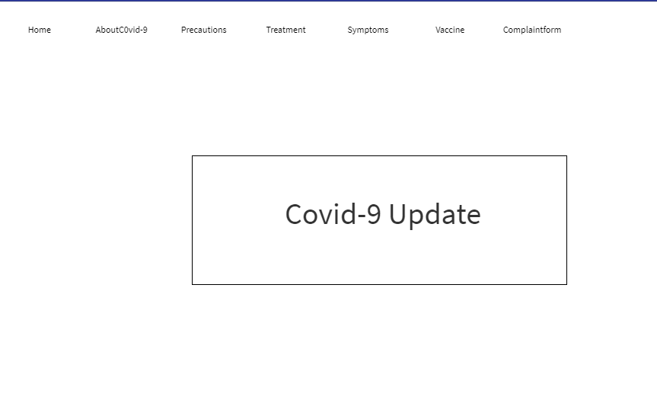

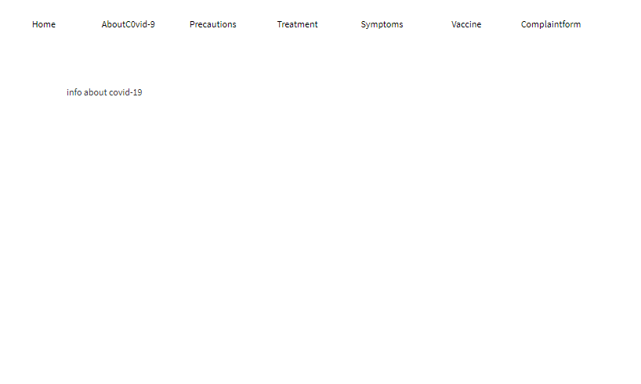

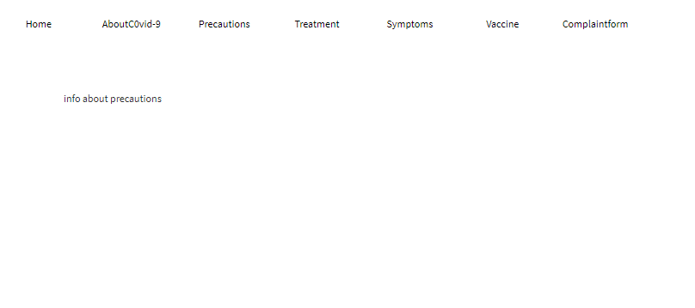

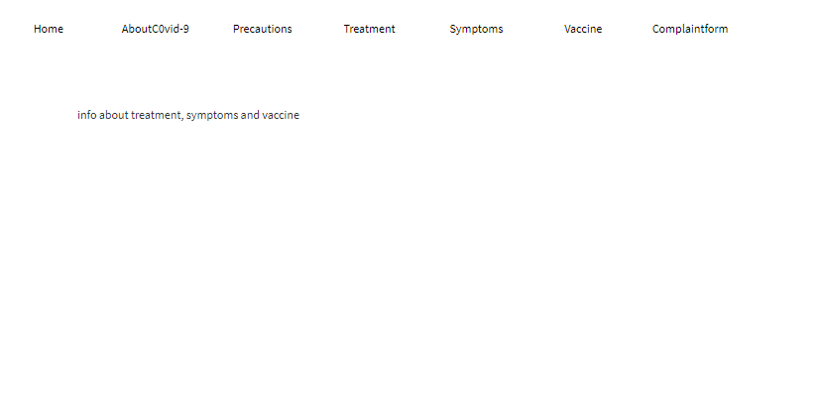

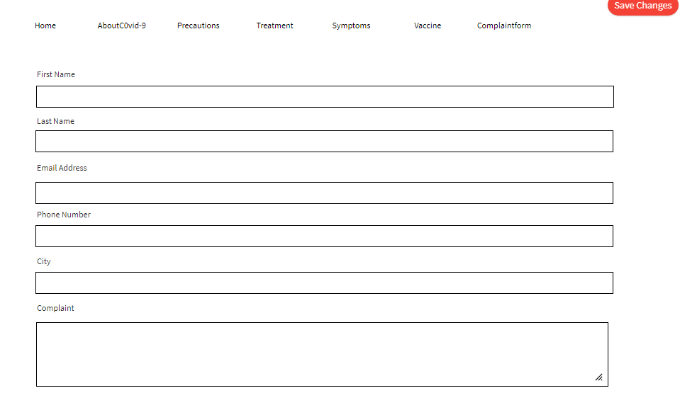

# **5. OUTPUTS**

